FOR IMMEDIATE RELEASE CONTACT PERSON
March 31, 2022 Aravind Menon
11:09 AM Epidemiologist,
888-669-7154
Weekly COVID-19 Risk Update
KEARNEY – Two Rivers Public Health updated the weekly risk dial on Thursday, March 31, 2022. The risk dial decreased within the green “low” level of risk.
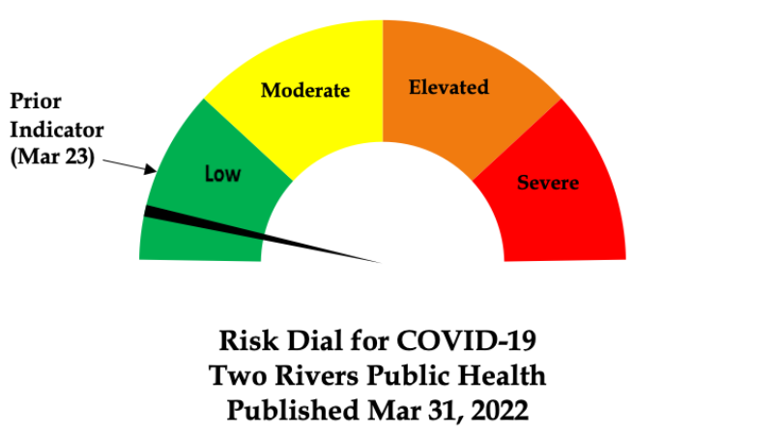
- 17 cases of COVID-19 were recorded in TRPHD between March 23 - March 29. In March 2022, TRPHD recorded the lowest number of monthly COVID cases (118) since June 2021, when 35 cases were recorded across the entire district. Also, as a result of decreasing cases and consistent level of low risk, the risk dial will now be updated bi-weekly unless there is an increase of risk.
- Test positivity rates outside of long term facilities are around 5%, and have remained at that level for over a month now.
- As of Mar 22, 52% of the total population of TRPHD has received the minimum prescribed dose of the COVID-19 vaccine. Booster doses of vaccines are recommended at 5 months after second dose (Pfizer/ Moderna) or 2 months after the first dose of Janssen COVID vaccine. As of Mar 29, 2022, half of TRPHD’s total population has either received a booster dose or are within the 2 or 5-month interval after their second vaccine dose,.
- As of Wednesday morning, over 30% of ICU beds in TRPHD and 40% of Medical/surgical beds in TRPHD were available. No COVID patients are currently on ventilator support in the district.
- TRPHD offers COVID testing at the Two Rivers Public Health Department office at 516 W. 11th Street, Kearney. Testing is offered Mondays & Wednesdays 9:30 AM – 10:30 AM. Those interested are required to register at https://login.registermytime.com/tw/2rphd for scheduling.
- TRPHD strongly urges all unvaccinated vaccine-eligible residents to avail of the COVID vaccination through their healthcare provider, pharmacy or TRPHD. For schedule of vaccination clinics, see https://www.trphd.org/covid-19/event-calendar.html/calendar/2022/4
- For these reasons, the risk dial is lowered from last week in the ‘low risk’ (green) zone. The dial reflects falling COVID incidence rates, improved ICU & Hospital bed availability and lowered COVID-related morbidity across the district.

ABOUT TWO RIVERS PUBLIC HEALTH DEPARTMENT
Two Rivers Public Health Department engages collaborative partners, community leaders and the public to promote healthy lifestyles, provide preventative education, assure environmental quality, and create more healthy and safe communities for all who live within the district. Follow TRPHD on Facebook and Twitter @2RPHD

