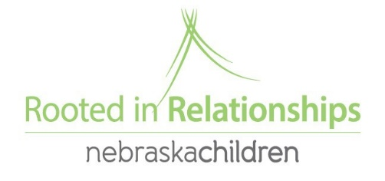

Positive Solutions for Families
A six-session free parent training series to provide information to families on how to promote children’s social and emotional skills, understand their problem behaviors, and use positive approaches to help children learn appropriate behavior.
*
Starting October 15,16,17, 22, 23, 24 , 2019
from 6:30 to 7:30 pm

Refreshments and childcare provided to those who pre-register!

CLASS NUMBERS ARE LIMITED SO SIGN UP TODAY!
Location:
Cozad United Methodist Church Fellowship Hall
1515 B Street Cozad NE
To register contact Suzanne at:
suzannemholmes@hotmail.com
OR call (308) 529-7275

Sponsored by Nebraska Children and Families Foundation Rooted in Relationships.

