

August 3rd, 2019

**Family Connect**

**9 am – 12 pm**

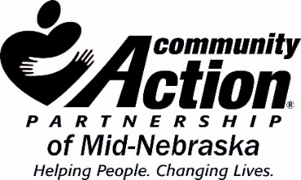

Presbyterian Church

801 N Lincoln St

Lexington, NE 68850

* This event will provide essential back to school services for children. Backpacks, school supplies, haircuts, snacks, L2 vouchers, hygiene kits, DHHS assistance, and much more to be announced.
* Any questions contact Martha Draskovic at: 308-324-4219. Limit 300.
* Bilingual Assistance Available